

# Code Documentation Last updated 01/19

# Contents

1. Globals  
1-1. Functions  
1-1-1. [ShootBullet(Transform startPosition)](#_1-1-1._ShootBullet(Transform_)

## 1-2. Variables

1-2-1. int sentryCount  
1-2-2. int gunmanCount

# 1. Globals

Image source: [wikipedia.org](http://upload.wikimedia.org/wikipedia/commons/7/77/Continents_from_globe.png)

# 1-1. Functions

## http://i.gyazo.com/4cdef8bd5f5095c042302fc2a75e13b6.png1-1-1. ShootBullet(Transform startPosition)

Is used to fire bullets using the position and rotation provided by the startPosition parameter.

Example:

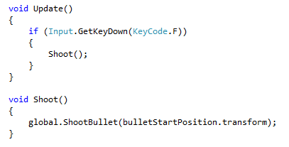

# 1-2. Variables

## 1-2-1. int sentryCount

http://i.gyazo.com/ed514325da4f3742c1a7437c623de545.png

Is used to get how many Sentries are in the scene.

Example:

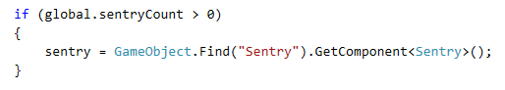

To avoid unnecessary searching, and later NullReferenceExceptions.

## 1-2-2. int gunmanCount

http://i.gyazo.com/842c6fc239674d94ebcf2c30259d64f3.png

Is used to get how many Gunmen are in the scene.

Example:

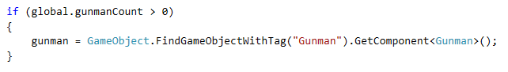

To avoid unnecessary searching, and later NullReferenceExceptions.